Animal Help
Create a Web page (HTML5 + CSS3 + images) that looks like the screenshot below:
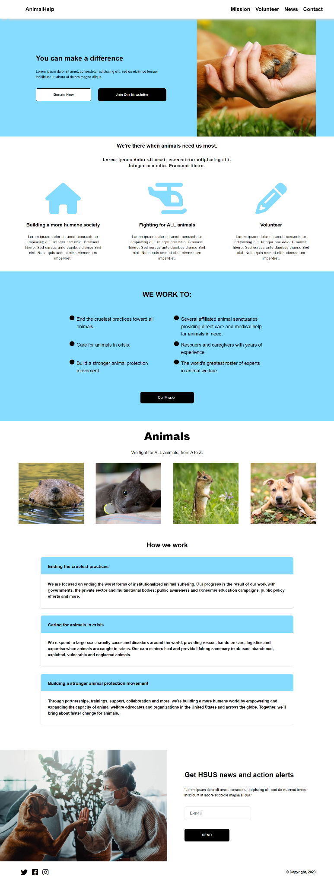
You are given the screenshot above + all required images.

Output
The output should be valid HTML5 + CSS3 + images that implement the web page above.

Constraints
- Use the following font: "Arial, sans-serif".
- The site should open correctly in the latest version of Chrome.

